REPORT SCREEENSHOT FOR BRIGHT IDEAS CONSULTING

1.Empathy Map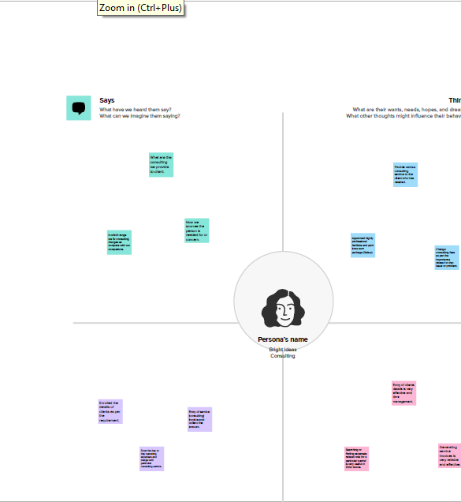

2. Ideation & Brainstorming Map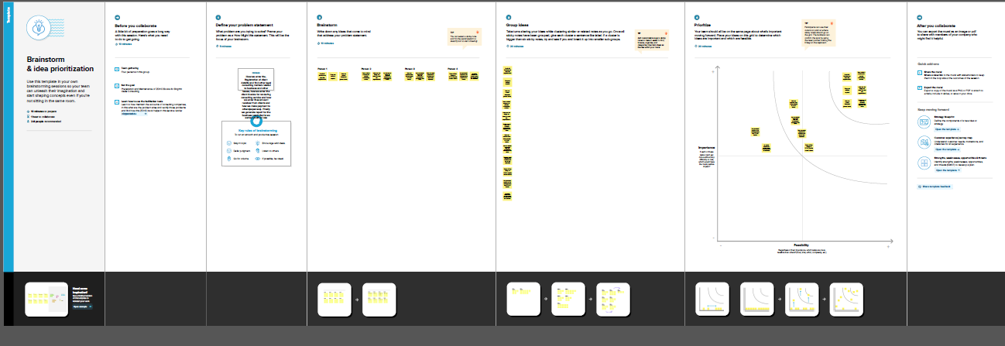

Generate the Financial Reports

1.Profit and Loss Account

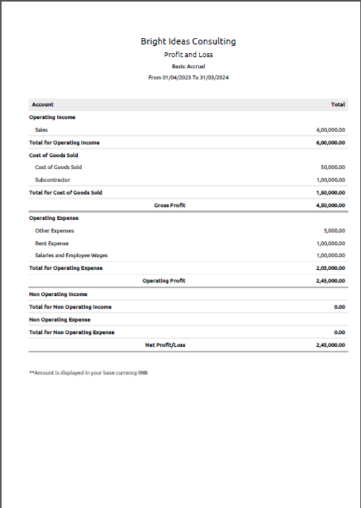

2. Balance Sheet

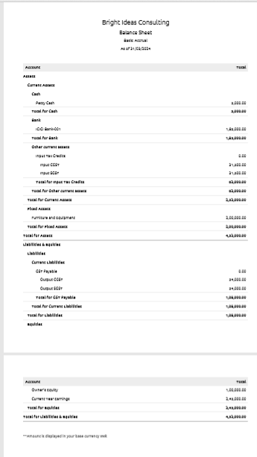

1. GST Reports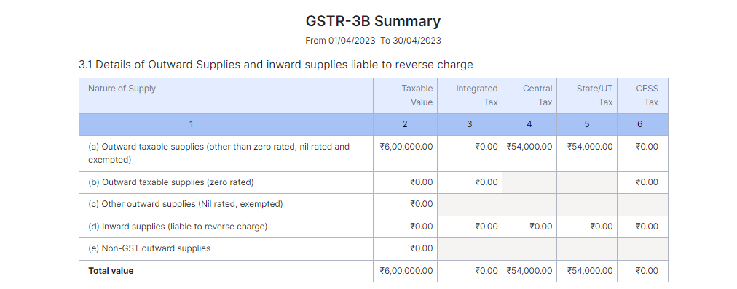

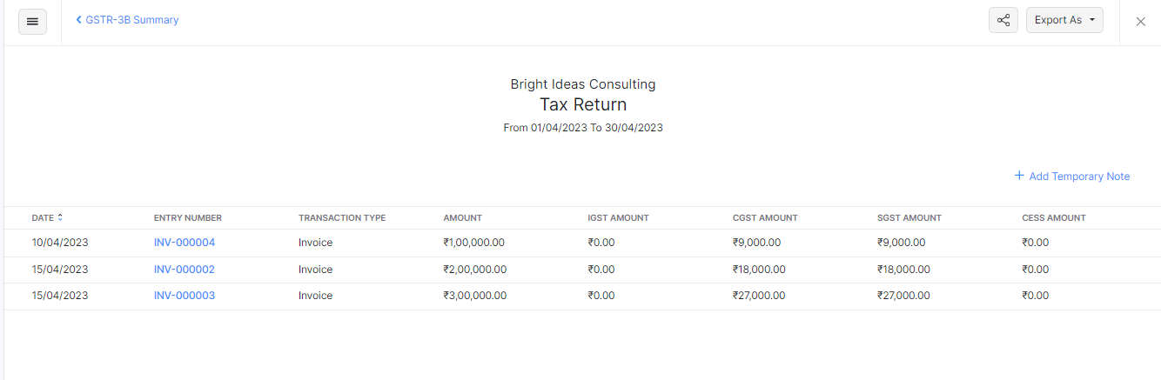

1. Journal Report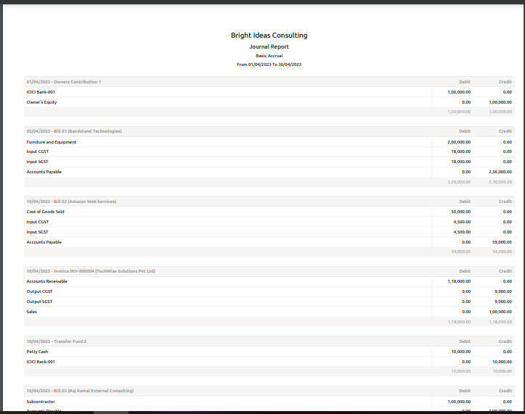
2. Accounts Receivable Summary

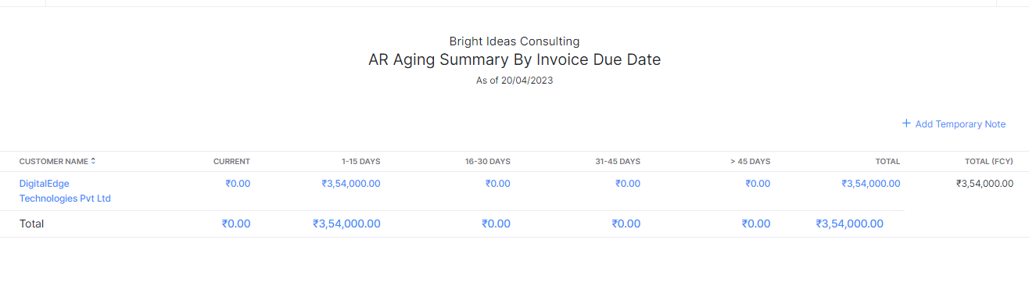

6. Accounts Payable Summary

